Use this provided relations to answer the following questions:
Relation 1: Event Relation 2: Participate
EventID | EventName | EventDate
1 | 100m Race | 2025-02-10
2 | Football Match | 2025-02-11
3 | Badminton Singles | 2025-02-12
ParticipateID | StudentName | Department | EventID
101 | Ayesha | CSE | 1
102 | Imran | BBA | 2
103 | Rumi | English | 3
104 | Sara | EEE | 4

Relation 3: Results
ResultID | ParticipateID | Position | Score
501 | 101 | 1st | 12.5 sec
502 | 102 | 2nd | 13.1 sec
503 | 103 | Winner | 2 - 0
504 | 104 | Runner-up | 18 - 21

- Write a SQL query to display each participates name with their position from the table.

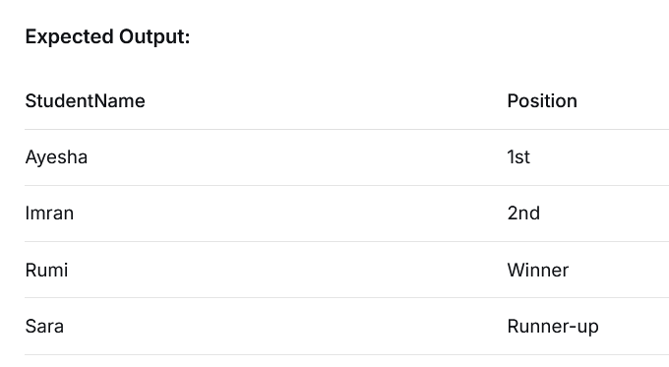
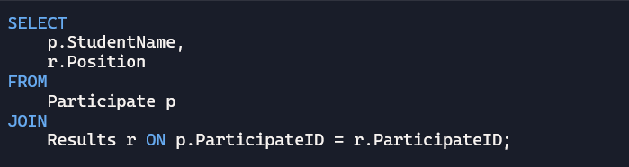

- Write a SQL query to show each department along with the number of participates who achieve any position/score in the results.
